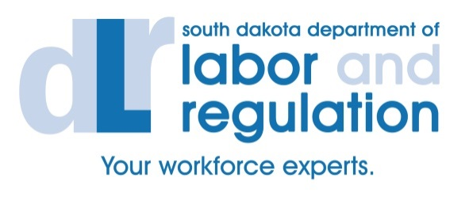
National Career Readiness Certificate
High School Junior and Senior Assessments

Please mail or fax this letter of application to:
Department of Labor and Regulation
ATTN: DOE NCRC
700 Governors Drive
Pierre, SD 57501
Fax: 605-773-6184 (Attn: DOE NCRC)

- School Name
- Address
- City
- Contact Name
- Contact Phone Number
- Contact Email
- Identify the number of students you will commit to assessing
- Identify the test group (juniors, seniors, or combination)
- List two possible dates that would work for you to offer the assessment

For more information on the NCRC program, please contact DLR Program Specialists:

Barb Unruh (West River) Scott Kwasniewski (East River)
700 Governors Drive 1310 Main Avenue South, Suite 103
Pierre, SD 57501 Brookings, SD 57006
605.773.5017 605.688.4352
barb.unruh@state.sd.us scott.kwasniewski@state.sd.us

Once this completed application is received and approved, the school representative designated above will be contacted by a DLR Program Specialist who will verify participation and coordinate assessment-day logistics.

