Ethical Dilemma Decision Tree
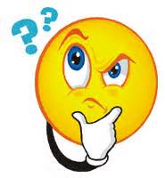

7. Make a decision.
- Remember, sometimes not making a decision is a decision.
6. What are the options?
- Best/Worst Case Result
- Will anyone be harmed by your decision?
5. Do I need help making this decision?
- Legal or regulatory?
- Seek Advice
4. What are the consequences?
2. What is the ethical dilemma, issue or problem?
3. Who is impacted by this?
- Stop and Think

