High School SPI Points Distribution:
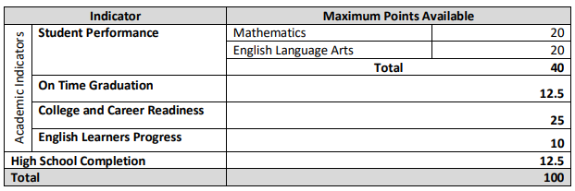

Elementary and Middle School SPI Points Distribution:
