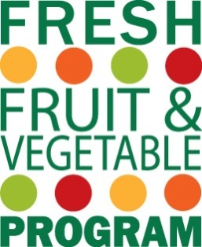
Request for Equipment Purchase for the Fresh Fruit and Vegetable Program
Instructions: Complete this form. Retain a copy for your files and return the original to the below address. DO NOT purchase equipment until approval is received from the Child and Adult Nutrition Service office.
Send the completed form to South Dakota Department of Education, Child and Adult Nutrition Service, 800 Governors Drive, Pierre, SD 57501, scan and email the form to doe.schoollunch@state.sd.us.

School Food Authority: _________________________________________________________________

Elementary School Name: _______________________________________________________________

- What is the piece of equipment to be purchased? Please describe what this is and its function.

- Why is this piece of equipment needed and why will current equipment not suffice?

- If replacing equipment, explain why the current equipment is being replaced.

- Compare multiple equipment options. How many different equipment options did you compare? Why did you select this piece of equipment versus another?

- How much administrative funding (10% of your FFVP grant award) do you have available for this purchase? $ ________________________

- How much does the piece of equipment cost? $________________________

- Will the equipment only be used for the FFVP? If the equipment will be used for multiple programs (NSLP), state the percentage each program is covering for the equipment cost.

- How many times do you serve fresh fruits and vegetable each week? ______________

- Remember to provide a printout of the selected product, indicating cost.

- Upon approval, submit a copy of the invoice to the CANS office.

If a school purchases a piece of equipment with FF&V Program funds, and then ceases to participate in the program in future school years, it is the responsibility of the state agency to direct the disposition of the equipment in keeping with guidance and the regulations at 7CFR3016.32©(1) and (e)(1) and (e)(2). In general, when the equipment is no longer needed for the original program or project, the equipment may be used in other activities currently or previously supported by a Federal agency.

_________________________________________ _______________________________________ ___________________________
Signature of Authorized Representative Title Date

_________________________________________ _______________________________________ ___________________________
Signature of Person Completing the Form Title Date

