Amazing Body Exhibit Tours South Dakota |  | 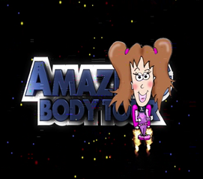
The Amazing Body Exhibit will be available to schools in the 2012 school year. Your school or after school program could be host to this set of 11 visual and interactive learning centers on body organs, nutrition, and physical activity. The exhibit consists of a) 11 animated lessons to be played on DVD via computer and/or LCD projector, b) tips to enhance each learning station, c) classroom follow-up activities, d) online evaluation tool. You will also be reimbursed for fruit and veggie snacks for youth who participate in the tour up to $125. To request the kit complete the form below.
LOCATION (School/center and city) | EVENT
CONTACT PERSON/EXHIBIT MANAGER | ADDRESS
PHONE | EMAIL
DATE FIRST CHOICE (Week of ____) | DATE SECOND CHOICE (Week of ___)
In exchange for the Amazing Body materials my school or agency agrees to the following:
- Provide staff or volunteers who can:
  - facilitate the lesson in each of the 11 stations
  - lead small groups of children from station to station
  - serve as the handler for the electronic equipment and DVDs
  - prepare and distribute fruit and vegetable snacks
- Include 3rd grade students and their teacher in a survey on what children learn from participating in the Amazing Body Tour. (You will be contacted with details.)
- Report on activities, return all DVDs, submit receipts for reimbursement for fruit/veggie snacks (reimbursed up to $125 for Fruit/Veggie snacks).
PLAN FOR IMPLEMENTATION (Type of event, how stations will be organized, key people involved, etc.)

SIGNATURE OF TEAM NUTRITION CONTACT PERSON |  |  | DATE

