School District Regions

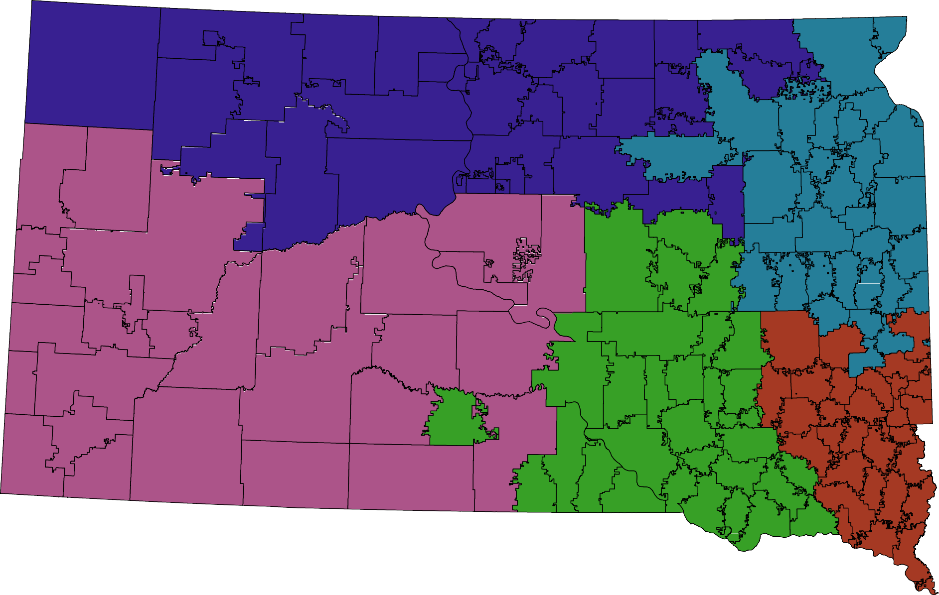

0 25
Region
1
2
3
4
5

50 100 Miles ®

