SAFE, DRUG & GUN FREE SCHOOLS
DATA SUBMISSION INSTRUCTIONS

Logging into the application

- Go to the website: https://www.state.sd.us/applications/DP42LaunchPad/Logon.aspx

- Enter the Login Name assigned to your district.
- Enter the password you chose to complete the submission last year. The password is case sensitive, so be sure to note whether using upper/lower case.
- Click on Submit.

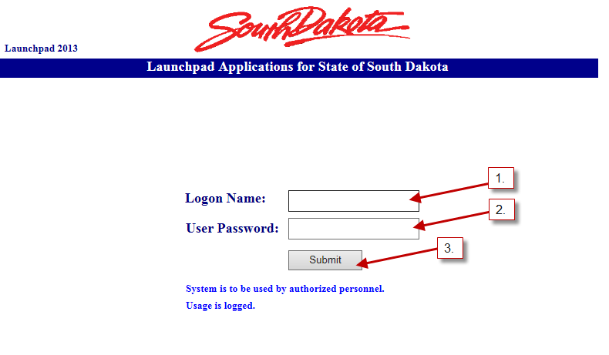

NOTE: If you cannot remember the password you set up last year, contact
Christina Booth at christina.booth@state.sd.us.

- You have now completed the login process and are at the application main menu.

- Click on Applications.
- Click on DE105EdSDGF.

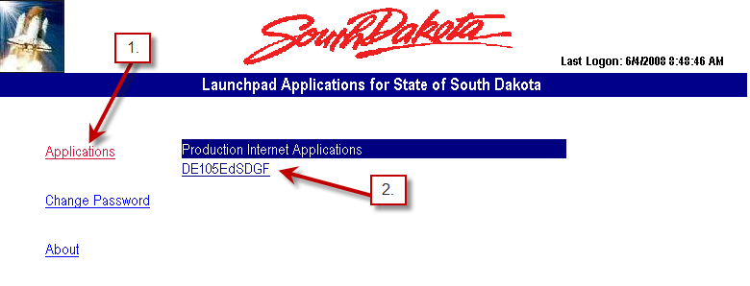

- Once logged in, click on “Update Contact Info”.
Note: you must complete the contact information section before the system will let you go any farther.

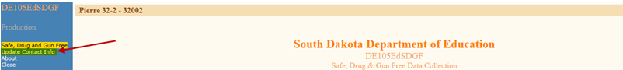

- Complete the Contact Information section.

- Enter your First Name.
- Enter your Last Name.
- Enter your Title/Position.
- Enter your Phone Number.
- Enter your E-Mail Address.
- Click on Save.

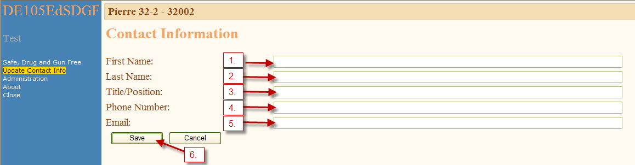

Instructions for encoding data into the application

- Note: An online dictionary of definitions is available, by moving your mouse over the word you want defined.

SCHOOL DATA

- From the menu on the left side of the screen, click on Actions, click on School Data and finally, click on Choose School.

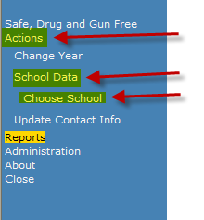

- The School Data must be completed for each attendance center listed. Click on the attendance center button that you want to complete.

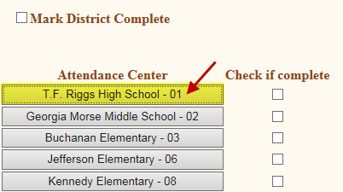

Incident Data

- Check the box next to each type of incident that occurred at this attendance center or choose No Criminal/Violent Offenses to Report.
- Click Save.

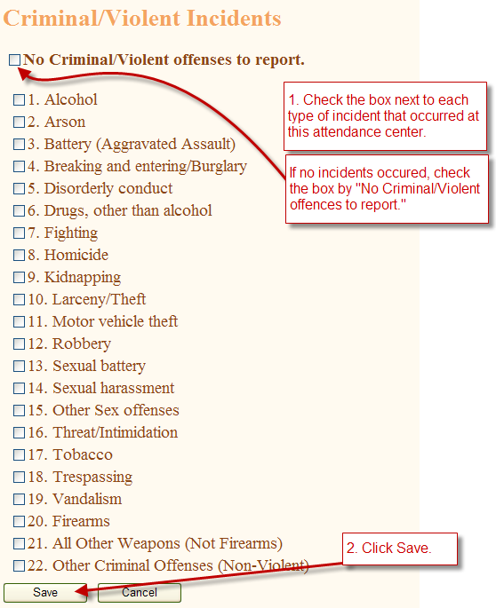

Encode Incidents

      - On the next screen, under Total Incidents, enter the total number of incidents that occurred per category.
NOTE: Data should be entered PER INCIDENT NOT PER STUDENT.
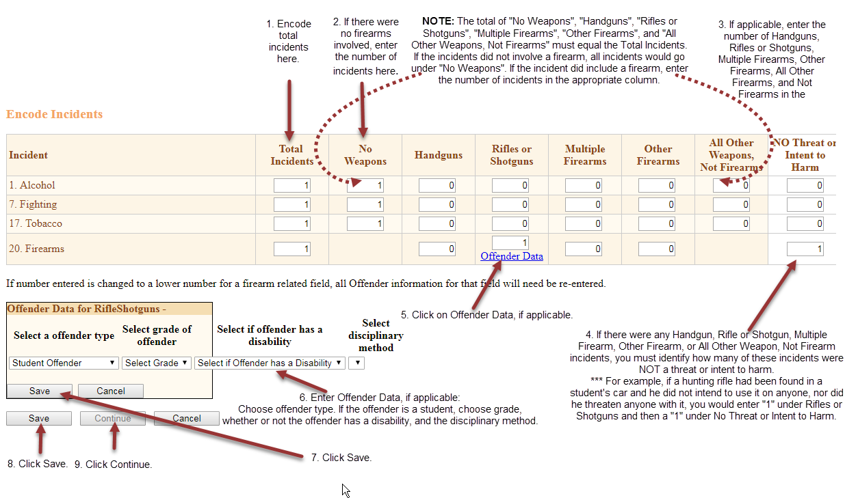
Note: The following columns must equal the total incidents: No Weapons, Handguns, Rifles or Shotguns, Multiple Firearms, Other Firearms, All Other Weapons (Not Firearms).
      - If the incident did not involve a firearm, all incidents would go under “No Weapons”. For example, if you had “1” Alcohol incident and there were no firearms, you would need to enter “1” under “No Weapons”. (See above.)
      - If there happened to be a firearm related incident that occurred in conjunction with another incident, enter the number of incidents in the appropriate column (handgun, rifle or shotgun, multiple firearms, other firearms, or all other weapons – not firearms).
      - If there was a firearm/all other weapons – not firearms related incident, you must then identify whether or not there was a threat or intent to harm. For example, if a hunting rifle had been found in a student’s car and he did not intend to use it on anyone, nor did he threaten a student with it, you would enter a “1” under Rifles or Shotguns, and then a “1” under NO Threat or Intent to Harm. (This is only required for firearm/weapon related incidents.)
      - Click Offender Data. (This is only required for firearm/weapon related incidents.)
      - Enter the Offender Data – offender type, grade, with/without disability, disciplinary method. (This is only required for firearm/weapon related incidents.)
      - Click Save. (This is only required for firearm/weapon related incidents.)
      - Click Save.
      - Click Continue.

Encode Offenders

- Enter the total number of offenders (unduplicated count) under each category for each type of incident. Click Save.

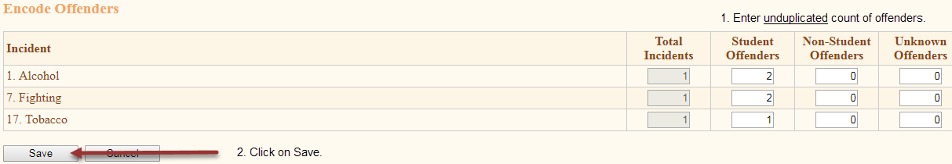

- Enter the total number of disciplinary actions under each category for each type of incident. Click Save.

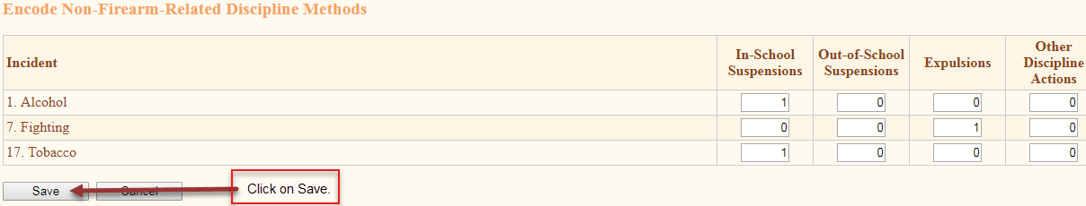

- Click the box under “Select” to complete additional information for Expulsion incidents. (If you did not have any expulsions, you will not see this screen.)

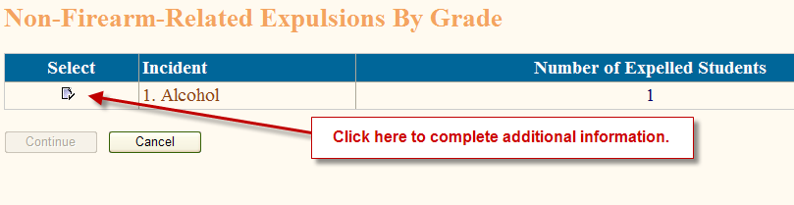

- Enter the total number of offenders by grade for Expulsion incidents. (You will only see this screen if a student was expelled because of a non-firearm related incident.)
- Click Save.

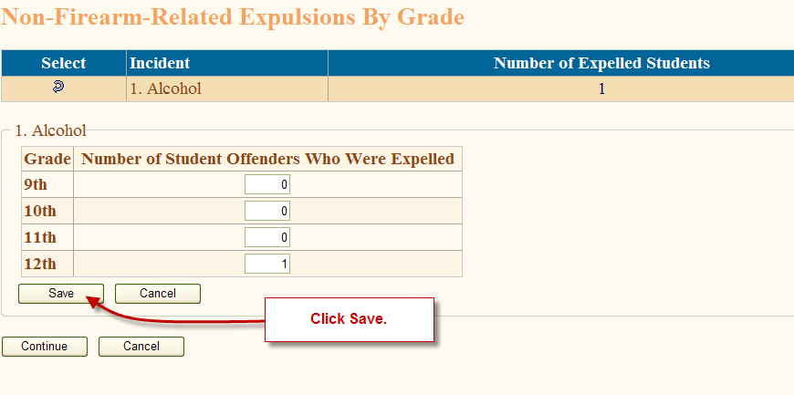

- Click Continue.

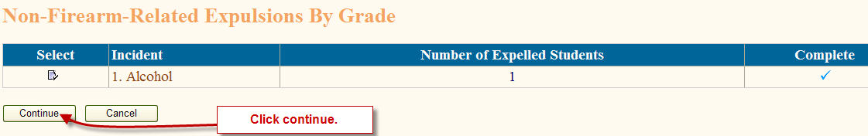

Services to Students

          - Identify, if any, the types of services/activities offered by the school during the reporting period. Choose all that apply.
          - Enter the number of students (unduplicated count) for which a truancy complaint was filed.
          - Click Save.

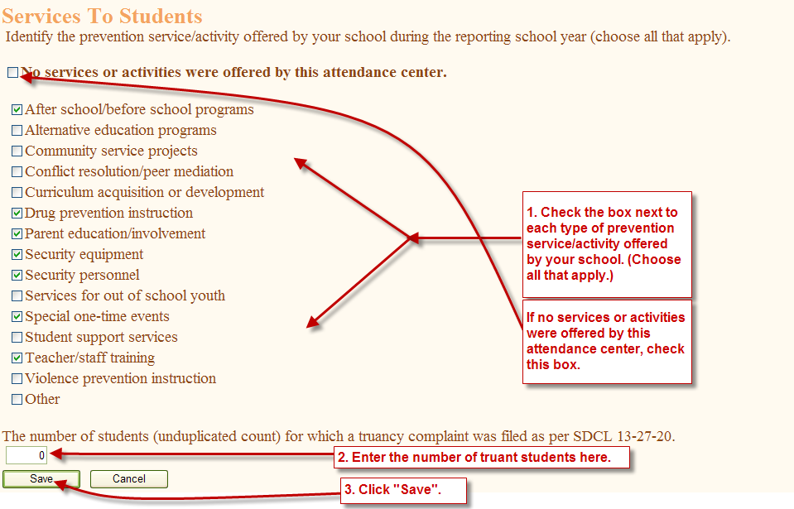

- Repeat the steps above for each attendance center.
- After all attendance center data has been completed and reviewed for accuracy, click on the box next to the name of the attendance center to mark it complete.

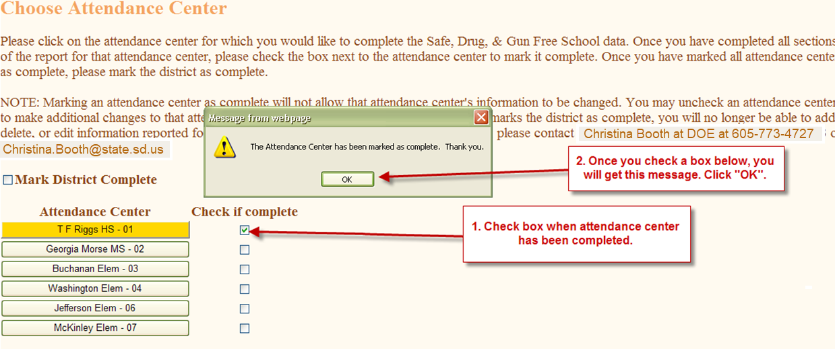

District Data

- The final step is to check the box next to “Mark District Complete”.

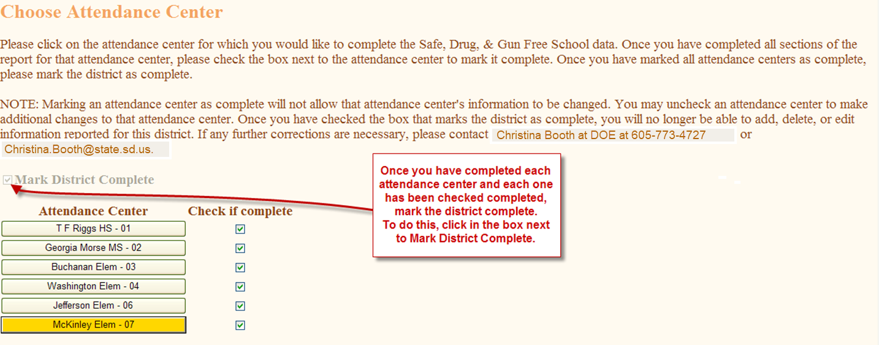

- Click “OK”.

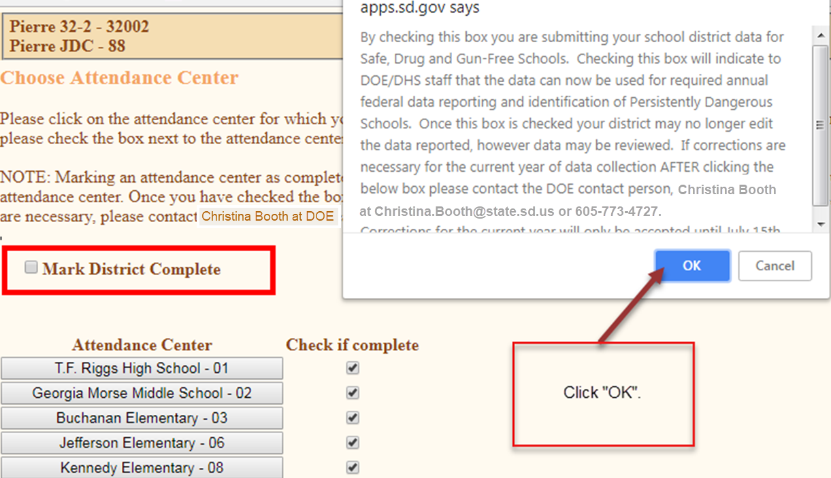

You have now completed the required reporting for the Safe, Drug and Gun Free Schools data submission.

Instructions for printing completed reports

- Click on Reports, from the menu on the left side of the screen.

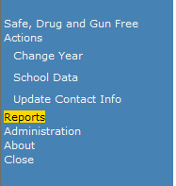

- This will bring up the Report Main Menu. At the top is a Report Group Box with a dropdown list of report options. Click on the dropdown arrow and select DE105-Report (District).

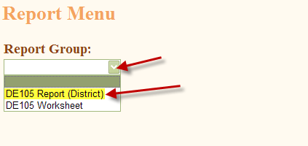

- There are 3 report options in this report group.

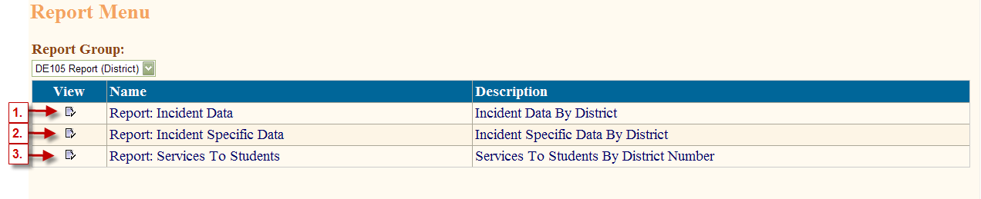

  - To print a copy of the district summary data, click on the box under View beside Report: Incident Data. You will then see the screen below. Make sure the school year shows “Current School Year” and click View Report.

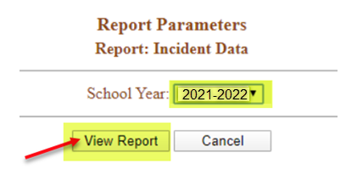

- Once the report is displayed, click on the Printer icon to print out a copy of the report.
- Close the report by clicking on the in the box at the upper right corner of the report.

  - To print a copy of the incident specific data, click on the box under View beside Report: Incident Specific Data. Make sure the school year shows “Current School Year” and click View Report.

  - To print a copy of the services to student’s data, click on the box under View beside Report: Services to Students. Make sure the school year shows “Current School Year” and click View Report.

    - To close the application, click on Close.



