Private Report Card
Navigation and Validation Guide
2019-2020
Updated August 2020

Contents
Private Report Card Access 2
Navigating the system 3
Different views for Report Cards 6
Overall Score Page 8
New Reports 10
Tools for Validation 11
Conclusion 13

Private Report Card Access

There are two types of accountability permissions: school or district. Permissions are assigned by the district’s STARS Account Manager. If users of STARS Account Managers have questions about SD-STARS accounts, login or permissions, contact STARSHelp@state.sd.us.

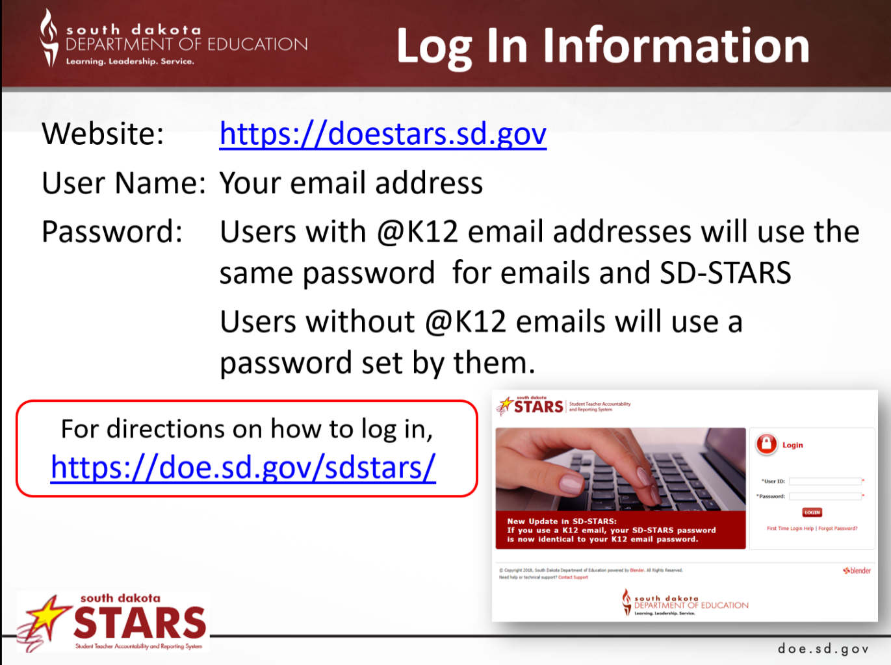

Navigating the system

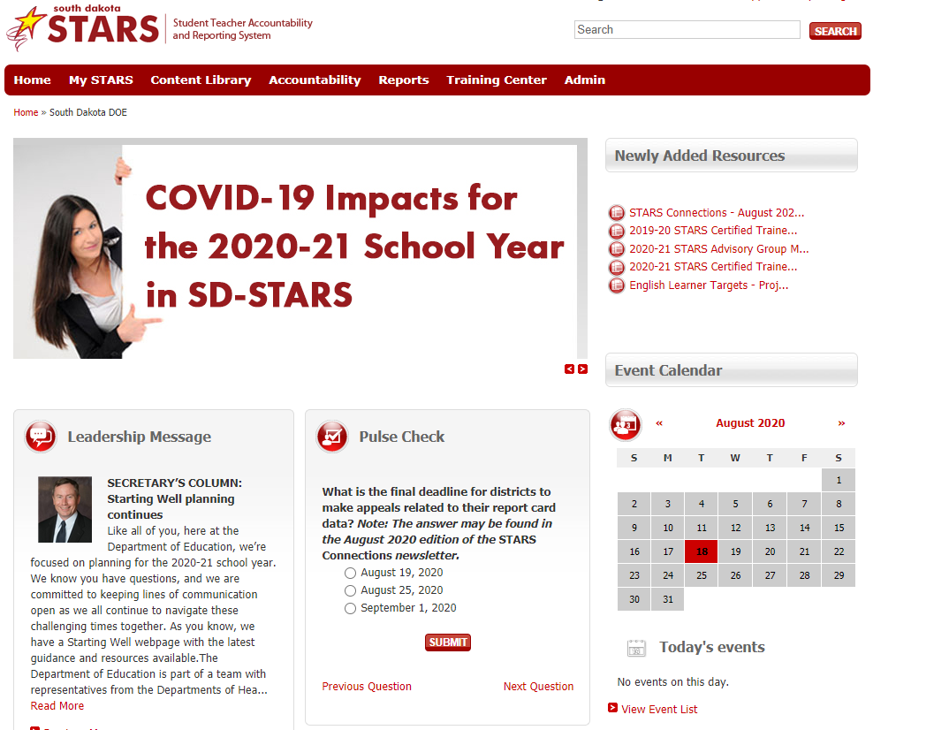
Once a user is logged in, the system will go to the screen below. From this page, users can access the Report Cards, Dashboards and Reports, along with a variety of other resource.

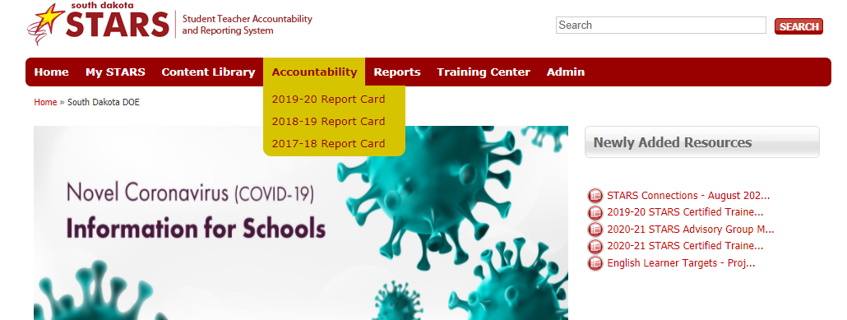
To access State, District and School level private report cards, click on Accountability.

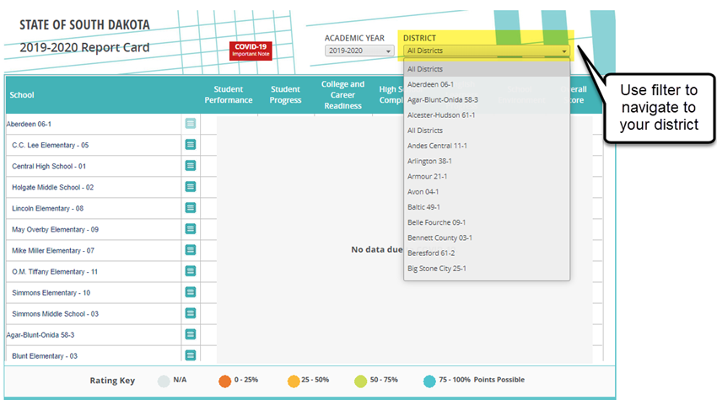
Once open, users can choose a variety of ways to access the data.
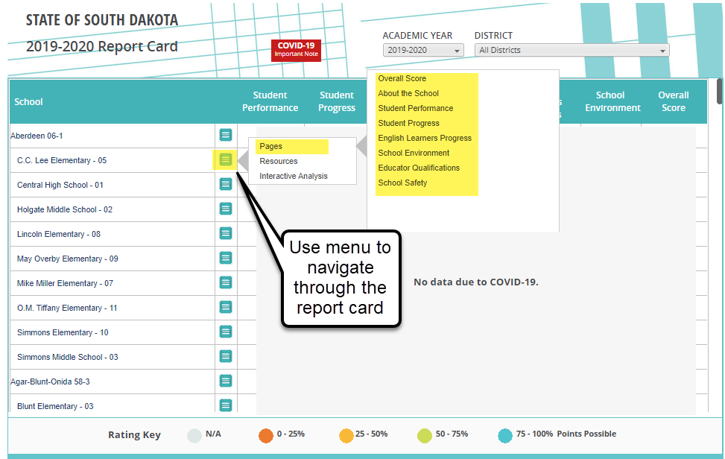
Reports and pages can be accessed by clicking on the blue square icon on Score Card pages. Below are screen shots of what can be accessed on each link. These links allow access to each page of a school’s report card from this initial page. The colored dots & overall scores are covered on this page and as well throughout the 2019-20 report card.
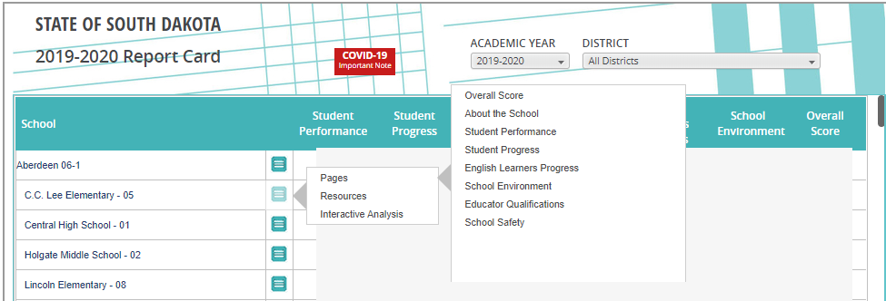
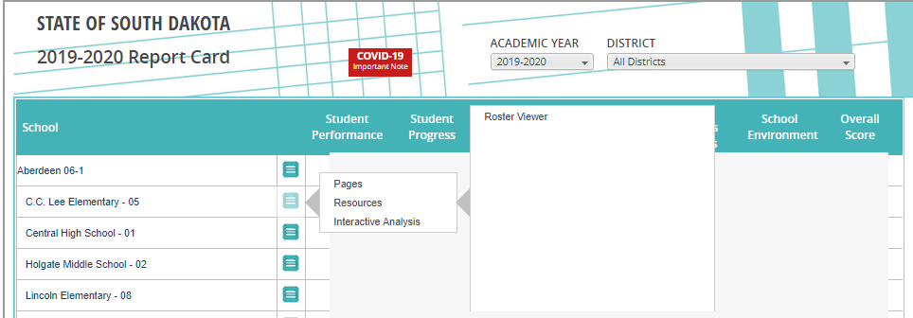
Getting to rosters:
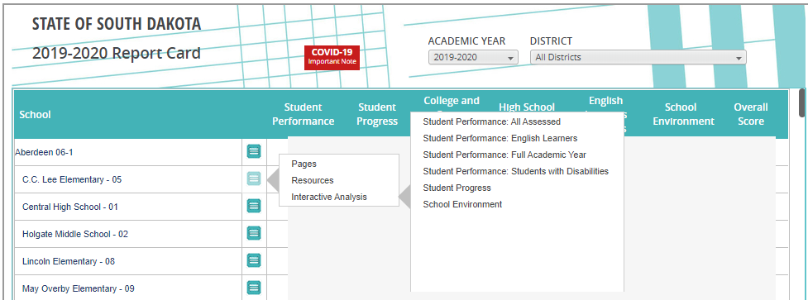
Getting to Interactive Analysis Dashboards:

Different views for Report Cards
Elementary and middle/junior high schools have different indicators displayed on the pages than the high schools report card pages. Report cards are available at the school, district, and state levels. On the next page a district and state report card are displayed (About the district/state page).
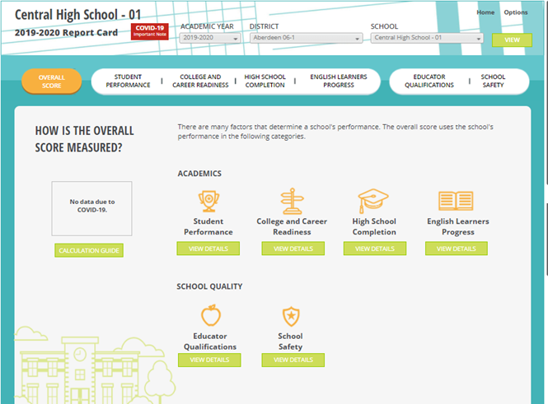
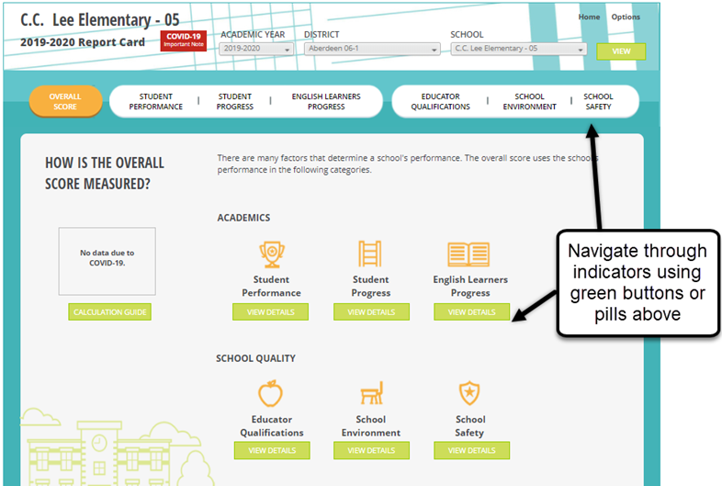

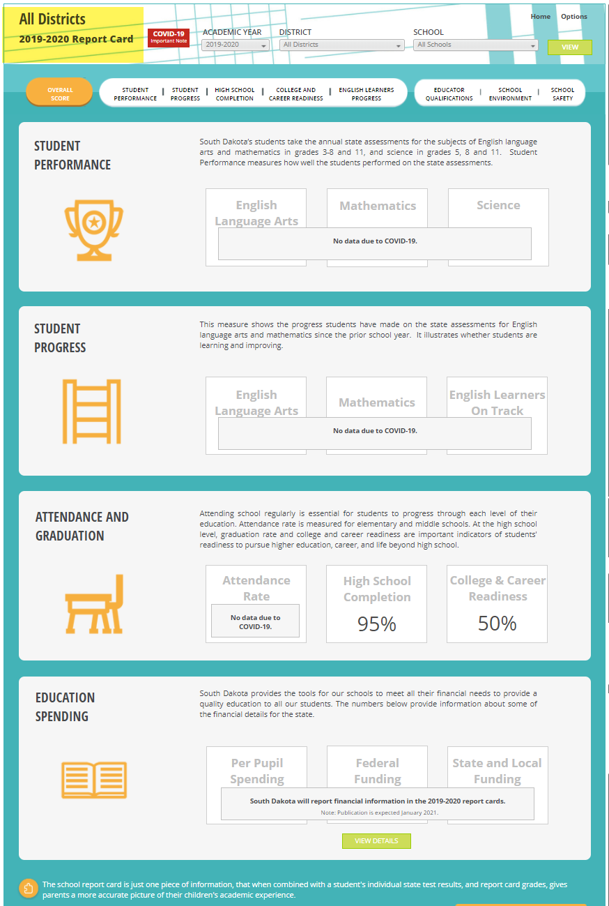
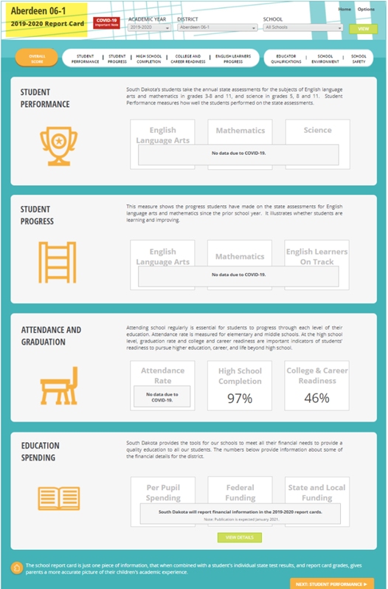

NOTE: When changing from one school to another, using the drop down box “School”, remember to click View after changing to another school.

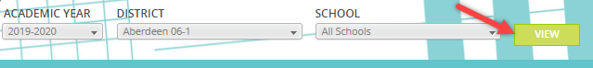

Overall Score Page
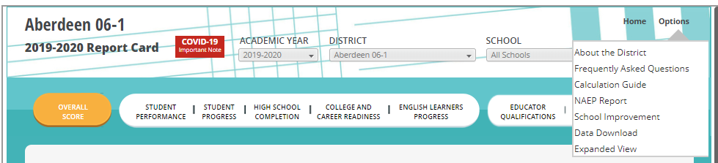
The Overall Score Page is the navigation starting point in to the report card. From this page, data can be accessed in a variety of ways including drop down menus, click on the Home or Options menus or the individual white oval indicator links. These ovals go from white to orange for the page you are currently in.

Tools for Validation
Different reports can be found by clicking on View Details and Student Roster. All reports can be exported to Excel. 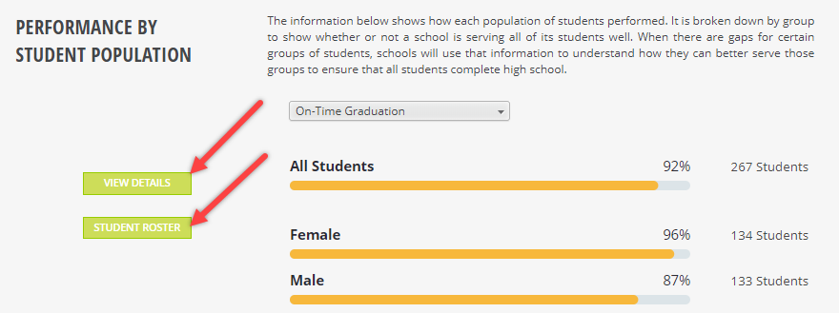
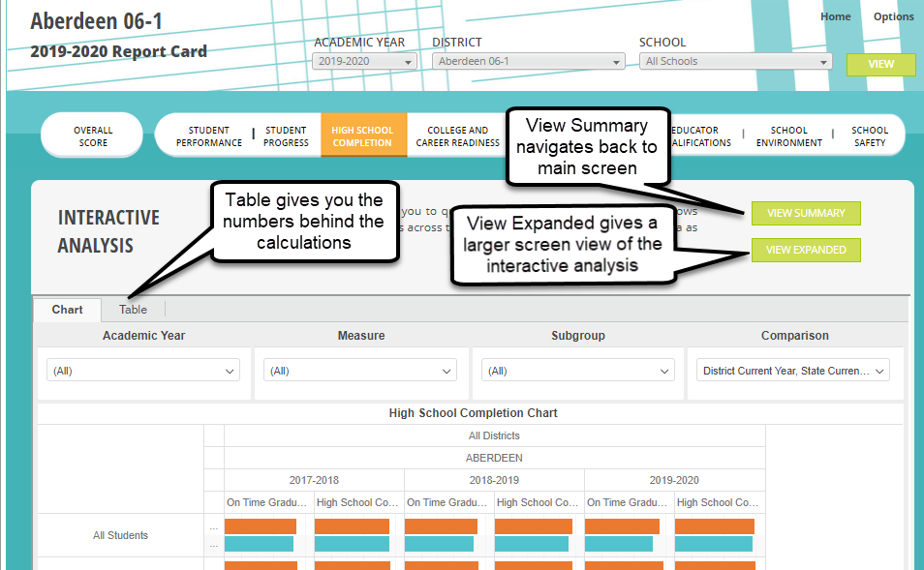
Clicking on View Details, will take you into the Interactive Analysis Dashboard where you can filter by academic year, measure, subgroup, and comparison.

Clicking the Student Roster button will open a roster dashboard with filtering & export features.
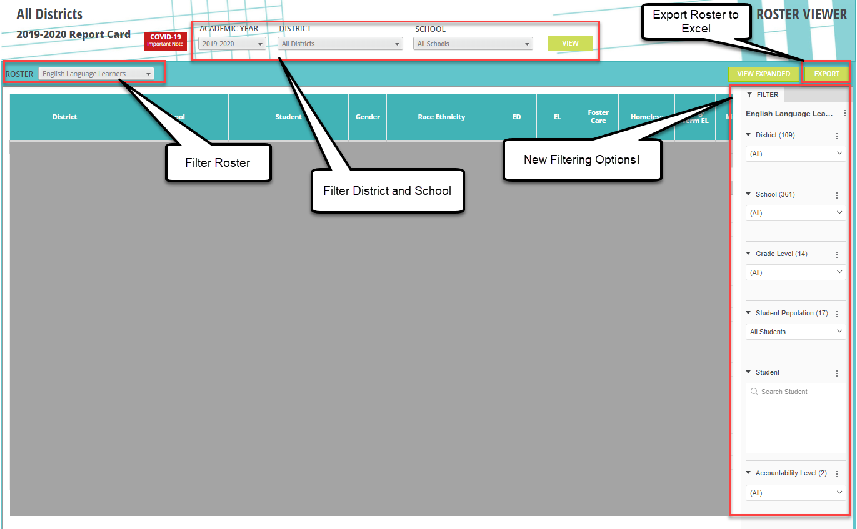
After clicking Export, the following screen will appear:
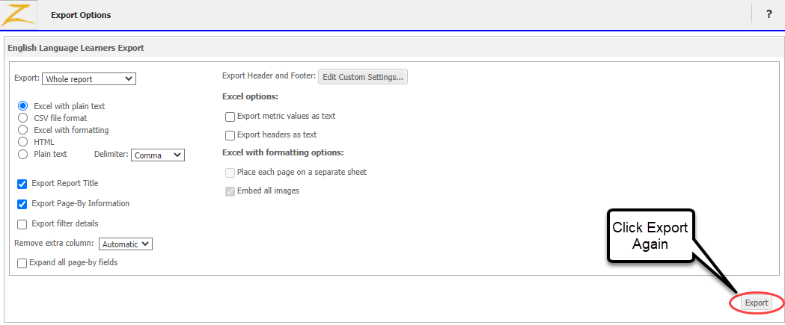
Conclusion

There are many tools in the updated report card to aid districts in data reviews and decisions. Other resources that districts might find helpful may be accessed by going to the South Dakota Department of Education website.

Resources
DOE Website: https://doe.sd.gov/
SD STARS website: https://doestars.sd.gov/login.aspx
Public Report Card: https://sdschools.sd.gov/#
DOE Accountability: http://doe.sd.gov/reportcard/

